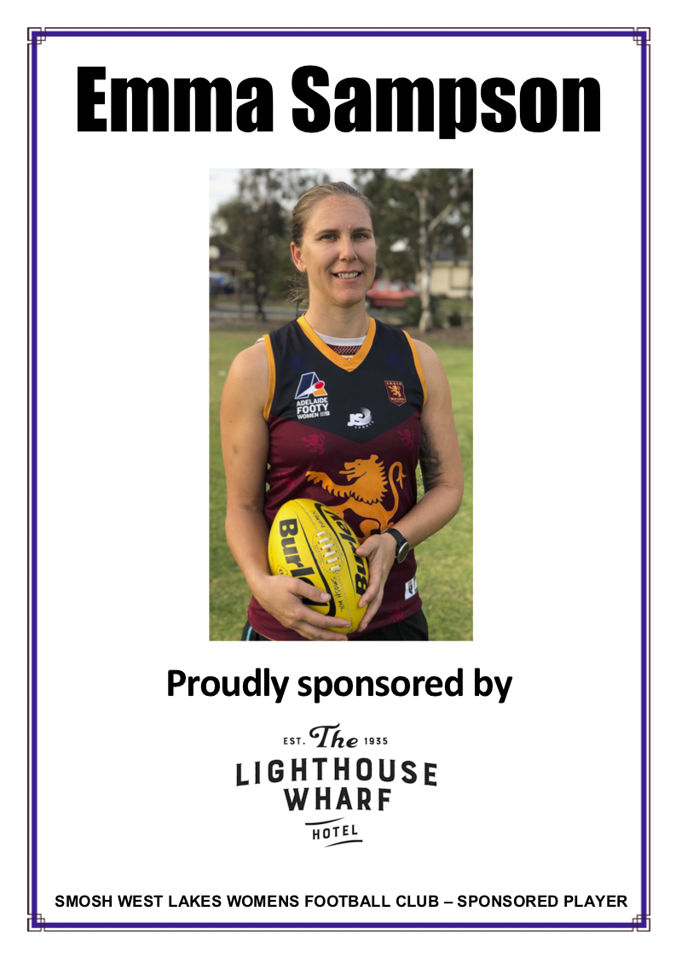
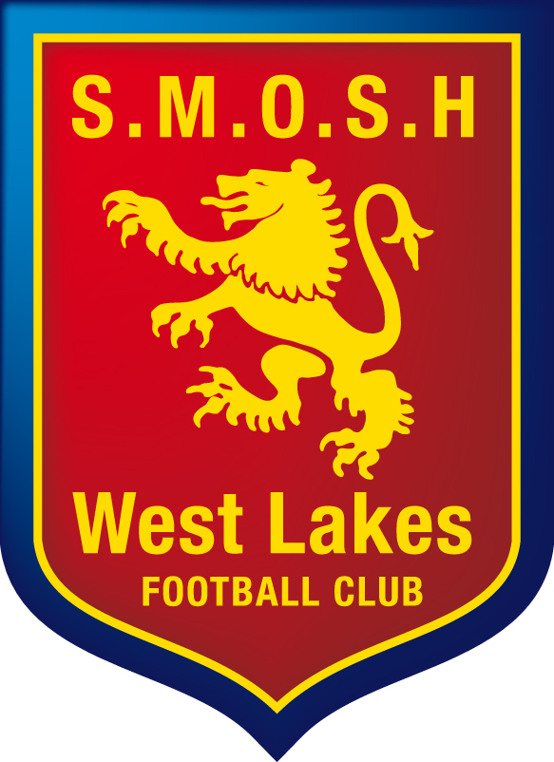
S.M.O.S.H. West Lakes
Women’s Football Club
Incorporation No. A43928
Bartley Terrace, West Lakes Shore
Public Relations Manager | Zac Cook
M: 0414 879 638
E: pr@smoshwlfc.com.au

Be a Women’s Player Sponsor

The S.M.O.S.H. W.L Women’s Football Club (the LIONS) is seeking your support. Following our inaugural 2019 season success where we reached the Grand Final, we are committed to achieving goals that relate to performance on and off the field in 2020. This is only achievable with the support of local sponsors who are open to building a partnership with SMOSH West Lakes and expand their reach into the community.

Our club has much to offer! It is renowned in the SAAFL as a club with a deep culture, great camaraderie and professionally run by enthusiastic volunteers. Those who are a part of the club believe it is an extension of their family and as such we would like to invite you to become a part of that culture by being a ‘Women’s Player Sponsor’.

Each player has been given the opportunity to not only contribute to the club on the field, but also seek a personal sponsor that they feel proud to introduce to the club. This initiative is designed to develop our player’s understanding of what a good club needs to do to survive, as well as introduce them to community businesses that wish to expand their networks.

As a Player Sponsor you are afforded:
- a player sponsorship poster, (see image above) that will be displayed above the Club’s bar and a copy provided to you for display in your business.
- invitation to special Player Sponsor and club events.
- business promotion amongst the club’s and your player’s social networks and home games throughout the year
- logo displayed on the player’s sponsor page of the club website.
- a feature in a club email if your player is identified as a key player or featured player.

Your commitment options:

- $400 covers your sponsored player’s fees
- $550 includes the above + a corporate 1m banner to be displayed at The Club

Where do we go from here? Simply complete the details on page 2 of this proposal and follow the instructions, or contact the Club’s Public Relations Manager (details above).
Step 1
Record the player’s name below, that you wish to support.

Player’s First name | Player’s Surname

Step 2
Supply a high resolution image of your business logo to the following email.

Email: pr@smoshwlfc.com.au
Subject: Player Sponsor Form & Logo
Image: .jpg .png files preferable (no larger than 10MB)

Step 3
Circle (or leave) the amount you wish to sponsor your player for – $400 / $550
Deposit the amount into the following account via EFT.

BSB | 105-142 (BankSA)
ACCOUNT | 056-789-040
NAME | SMOSH West Lakes Womens
REFERENCE | <BUSINESS NAME> <PLAYER SURNAME> abbreviate if necessary

Step 4
Provide your details below and Sign this form, and either; return to the SMOSH West Lakes Public Relations Manager at the following address: 1 Baroda Ave, NETLEY SA 5037 or scan and email along with your business logo (as per details above).

Your Name
Business
Address/email | @  Postal:
Phone
Mobile

Signature | I have followed these steps above. Please sign.

Thank you for supporting the S.M.O.S.H. W.L. Women’s Football Club – the LIONS.
Your receipt will be emailed to you upon remittance of our account.

Brief Club History
The SMOSH West Lakes Women’s Football club in 2020 is in its second season following a successful 2019. Stemming from the success of the Junior Girls program lead by Anthony Forby. The formation of the club has been made possible by dedicated members of the Senior Men’s and Junior clubs. However, the women’s program starts as far back as the paths forged by our own Erin Phillips who played in the boy’s junior squads until she was 14 years who took out the best and fairest for her age group. Now, her father Greg Phillips is leading the club as senior coach and will forge a legacy (again) to pave the way for girls to play senior women’s footy.

